Chapter 8, Solution 44.

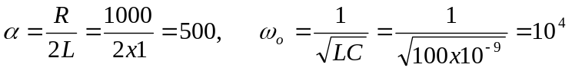

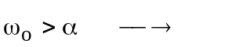underdamped.

